Ideation Phase
Define the Problem Statements

Date | 31 January 2025
Team ID | Team 10
Project Name | Import Data using Transform Maps (Spreadsheet)
Maximum Marks | 2 Marks

Customer Problem Statement Template:
Create a problem statement to understand your customer's point of view. The Customer Problem Statement template helps you focus on what matters to create experiences people will love.
A well-articulated customer problem statement allows you and your team to find the ideal solution for the challenges your customers face. Throughout the process, you’ll also be able to empathize with your customers, which helps you better understand how they perceive your product or service.

Reference: https://miro.com/templates/customer-problem-statement/
Example:
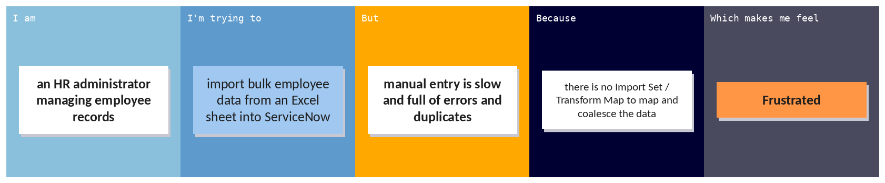
Problem Statement (PS) | I am (Customer) | I’m trying to | But | Because | Which makes me feel
PS-1 | HR admin who manages employee records in ServiceNow | Import bulk employee data from an Excel spreadsheet into ServiceNow quickly and accurately | Manual entry is slow, and records contain errors and duplicates | There is no Import Set and Transform Map to map spreadsheet fields to the target table and coalesce on Employee ID | Frustrated and worried about data accuracy
PS-2 | HR manager who monitors employee data | View employee distribution by department and location in one place | Data has to be analysed manually and insights are delayed | No reports or dashboard are built on the imported Employee Test table | Uninformed and unable to make quick decisions

